◎油浸式电流互感器简介◎
◆Brief introduction to Oil-immersed Current Transformer◆

本产品符合国家标准GB1208-2006《电流互感器》和国际电工委员会标准IEC 60044-1：2003《互感器 第1部分：电流互感器》的要求，主要供35kV、110kV、220 kV，50Hz电力系统作电流、电能测量和计量及继电保护用。
The products comply with the requirements of GB1208-2006 “Current Transformer” and International Electro technical Commission IEC 60044-1：2003 “Instrument Transformers Part-1 Current Transformers”. It is mainly used for current and electric energy measurement and relay protection for 35kV, 110kV and 220kV, 50Hz power system.

产品安装地点的环境温度为-30℃～+40℃，海拔不超过1000m，高原型产品海拔不超过3500m。普通型产品适用于一般地区，耐污型产品适用于Ⅱ、Ⅲ、Ⅳ级污秽地区，组合型产品专与隔离开关配套成组合电器。
Environmental temperature of its assembly place is -30℃～+40℃, altitude above sea level shall not exceed 1000m, Altitude for plateau type product shall not exceed 3500m. Common product apply to common place, Anti-pollution products can apply to Ⅱ、Ⅲ、Ⅳ pollution area, Composite type products form composite electrical apparatus specialty combining with isolating switch.

产品型号表示方法及字母意义：
Way of showing the type of product and meaning of letters:
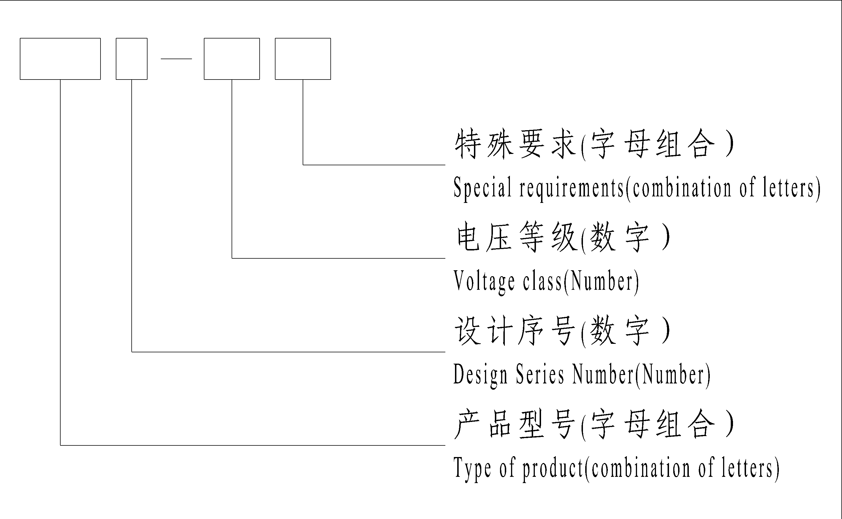
产品型号：L—电流互感器，V—倒立式，B—有保护级，T—具有暂态特性，C—瓷绝缘，W—户外型，A—结构型式为“链”型，N—油保护方式不带金属膨胀器。
特殊要求：TA—适用于干热地区；TH—适用于湿热地区；GY—适用于高原地区；ZH—与隔离开关配套；W1—适用于Ⅱ级污秽地区；W2—适用于Ⅲ级污秽地区；W3—适用于Ⅳ级污秽地区。
说明：
(1)以下所列技术参数仅供设计或选用时参考，可随用户的要求不断改进，各种产品的主要技术参数以产品的铭牌为准
(2)我厂产品型号按新标准要求，经批准注册，原LCWB-110，LCWB-220型分别改型为LB7-110，LB9-220型，并重新通过了国家电力公司和国家机械工业局联合组织的批量生产鉴定。
Type of product: L—Current Transformer, V—Inverted type, B—With Protective Class, T—Transient performance，C—Porcelain insulation，W—Outdoor type. A—the structure is with ‘chain’ type, N – Oil protection without metal expander.
Special requirements: TA—Apply to dry and hot area, TH—Apply to humid and hot area, GY—Apply to plateau area, ZH—combining with isolating switch, W1—Apply to class Ⅱ pollution area, W2—Apply to class Ⅲ pollution area, W3—Apply to class Ⅳ pollution area.
Note：
(1)The following listed technical parameters are only for reference when design and selection. It can be improved as required by customers. All kinds of main technical parameters are based on nameplate of product.
(2)Product type of our factory comply with the new standard, upon approval and registration, former LCWB-110, LCWB-220 are changed into LB7-110, LB9220, and the products has passed again batch production. Appraisal organized by National Power Company and National Mechanical Industry Bureau.

LCWB-35W和LABN-35W型电流互感器由器身、金属膨胀器、瓷套、底座等组成，系全密封结构。器身呈“8”字形，上半部分为一次绕组，下半部为二次绕组。
Current transformer with type of LCWB-35W and LABN-35W is composed by body, metal expander, porcelain shell, base and so on, the products are full-sealed structure. Its structure appears like the number “8”. The upper part is primary winding, the lower part is secondary winding.

LVB-35W和LVBT-35W型电流互感器采用油纸倒立式全密封结构。主要由躯壳、底座、瓷套、金属膨胀器、器身，一次导杆、一次出线装置和二次出线盒等部分组成。器身为吊环形，主绝缘全部包在二次绕组上，一次、二次绕组均置于产品的头部，产品内充变压器油，膨胀器装在躯壳上部起全密封和油温变化时体积补偿作用。该型产品是一种低漏磁电流互感器，没有返回导体电流产生的磁场对二次绕组的干扰，这样提高了二次绕组的保护、测量和计量的准确度。该型产品的介质损耗因数小、局部放电量低；该型产品的额定一次电流可达数千安，可保证足够大的动热稳定电流；该型产品可以任意组合二次绕组，带负载能力强，可带多种变比抽头，从而实现各种规格的测量和保护的需要；可以按用户要求带TPY绕组，从而满足用户快速继电保护的要求。
Current transformer with the type of LVB-35W and LVBT-35W is with oil-paper inverted full-sealed structure. It is consist of shell, base, porcelain bushing, metal expander, body, primary pole, primary terminal device and secondary terminal box and so on. Body is ring shaped, main insulation is wound round the secondary winding, primary winding and secondary winding are on the top of the products, the products are full with oil transformer, expandar is fixed on the top of the body shell working as volume compensation and full-sealing when oil temperature changes. The CT is with low leaking-magnetization, and without interference caused by magnetic field which is without returning-conductor current to secondary winding, therefore, protection accuracy and measurement accuracy and calculation accuracy of secondary winding are improved. This CT is with low dielectric loss and low partial discharge. Its rated primary current is up to several kilo amperes, adequate dynamic current is guaranteed. its secondary winding can be combined at random. And it is with strong load and with taps with several ratios so that the product can reach the requirements of measurement and protection. TPY winding can be provided according to consumer’ requirements, therefore, the consumers can quickly reach the requirements of relay.

LB7-110W和LB9-220W型电流互感器产品由油箱、瓷套、金属膨胀器、器身、一次出线装置和二次出线盒等部分组成，属全密封结构。器身包括一次绕组和二次绕组，经真空干燥和浸渍处理后，浸于变压器油中，变压器油经真空过滤，作充分的脱水、脱气处理。整个产品绝缘电气强度高，且介质损耗和局部放电量低。一次绕组成“U”形，为电容型油纸绝缘结构。一次绕组分成两段，四个出头通过一次出线装置在瓷套上部侧壁引出，可方便地在外部进行串并联换接，以改变电流比，二次绕组在环形铁心上，可以带中间抽头。
CT with the type of LB7-110W and LB9-220W is composed by oil tank, porcelain shell, metal expander, body, primary terminal device and secondary terminal box and so on. It is a full-sealed structure,. Its body composed by primary winding and secondary winding, upon vacuum drying and impregnating treatment, the products shall be immersed in the transformer oil , after vacuum filtration of transformer oil, dehydration and degassing treament shall be done. Insulation of products has high electrical strength, low dielectric loss and low partial discharge. Primary winding is like the letter “U” and is with capacitance type oil paper insulation structure. Primary winding is composed by two sections, four taps are drawn out at each side of upper part of porcelain shell through primary terminal device for series connection and parallel connection conveniently so as to change transformation ratio. Secondary winding are wound round the ring core, middle taps may be provided, if needed.

LBT-220W型具有暂态特性电流互感器供500kV电力系统220kV侧作快速继电保护用。性能符合国家标准GB1208-2006《电流互感器》和国际电工委员会标准IEC60044-1：2003《互感器 第1部分：电流互感器》及GB16847-2006《保护用电流互感器暂态特性技术要求》的要求，满足电力系统各种快速保护对暂态误差的要求，并能保证系统可靠的自动重合闸。本型产品为全密封结构。产品顶部装有金属膨胀器，用于补偿油体积随温度发生的体积变化。一次绕组采用油纸电容型绝缘结构。二次绕组均置于“U”形一次绕组的P1侧，铁心为环形，保护绕组采用优质硅钢片绕制，并经退火处理，TPY级铁心设有非磁性间歇，TPY绕组设有平衡绕组。
Current Transformer with the type of LBT-220W with transient performance works as relay quick protection for 500kV power system 220kV side. The performance is in accordance with the requirements of GB1208-2006 《Current Transformer》and standard IEC60044-1: 2003《Transformer The first part: Current Transformer》of International Electrical Committee and GB16847-2006《Technical requirements of Current Transformer with transient performance for protection》, and it can meet the requirements of all quick protection for transient tolerance in Power System, and it guarantee reliable system re-closed self-switch. This kind of CT is full-sealed structure. There is a metal expander on the top of the products working as compensation action on volume when the oil-temperature changes. The primary winding is with oil-paper capacity insulation structure. The secondary winding is on the side of P1 of primary winding with the letter “U” shaped, the core is ring shaped, excellent silicon pieces shall be used for common protection, which is treated by annealing, TPY Class core is fixed with non-magnetic space, TPY winding is fixed with balanced windings.

★金属膨胀器
★Metallic expansion bellows

我公司生产的LCWB-35W、LB7-110W、LB9-220W、LBT9-220W等型电流互感器均采用全密封结构。这些型号电流互感器均选用金属波纹膨胀器作为油体积补偿装置，金属波纹膨胀器的型号为PB250、PB460、PB480、PB₃-480。这些型号的膨胀器具有油位显示直观、压力反映灵敏和较好的防爆功能等优点。
金属波纹膨胀器安装在产品的顶部。其主要构件是采用不锈钢材料(1Cr18Ni9Ti)制成，罩壁上设有视察窗和油温标定线，通过视察窗可观察到油温的变化情况。金属膨胀器能使电流互感器内部长期保持微正压，确保产品内部的变压器与外界大气完全隔绝，从而保证产品的安全运行。
CT with the type of LCWB-35W, LB7-110W, LB9-220W, LBT9-220W and so on manufactured by our company is full-sealed structure. Metal wave expander is used working as compensation device for oil volume, and the type of metal wave expander is PB480, PB460, PB250, PB3-480 which has advantage such as audio-visual indication and sensitive pressure rection and good anti-plosive.
Metal wave expander is fixed on the top of products working as compensation action on volume when oil-temperature changes, the main parts apply to stainless steel material(1Cr 18Ni9Ti). there are Window and indicating line of oil temperature are fixed on wall of the cover of metal wave expander, where can observe change of oil temperature . CT with metal expander keeps micro-pressure, it guarantee that the internal transformer of products can be completely isolated from external atmosphere, so CT with metal expander can guarantee reliable operation.
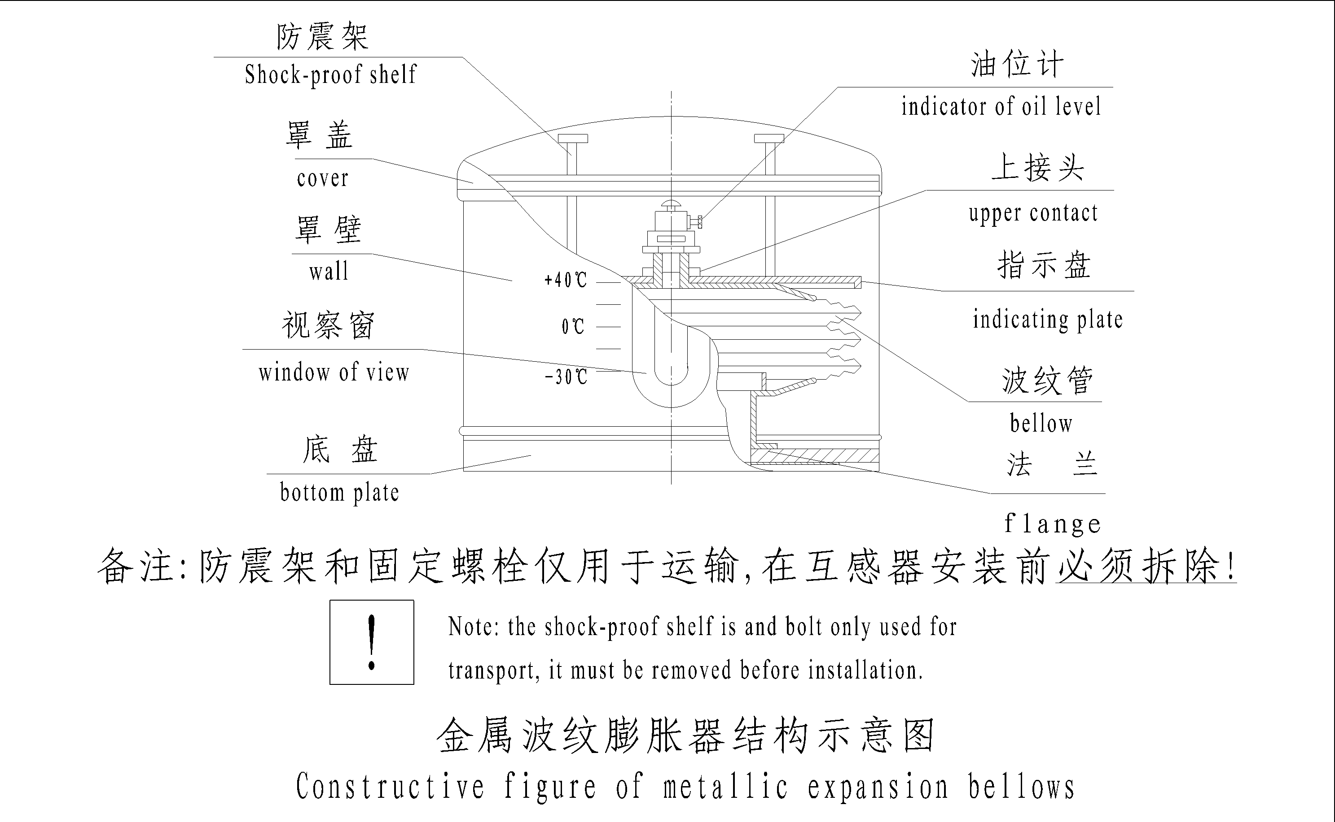

★全密封取油样自封阀
★Full-sealed oil-sampling valve
互感器下部设有不锈钢全密封取油样自封阀。这种取油阀取油或注油非常方便，密封性能可靠。产品取油样或加油时拧开阀罩，将取油(充油)接头套上阀体旋入,在取油(充油)接头的油嘴处套入取油管, 取油(充油)接头旋转到位，即可实现全密封取油样或加油（见图）。
Full-sealed oil-sampling valve with stainless steel material is fixed on the lower of oil bank under the transformer. This kind of valve is convenient for operation of oil-out or oil-in, the seal performance is reliable, The cover of valve shall be opened when in operation of oil-out or oil-in , the oil-sampling contact shall cover with valve, and oil-sampling tube shall cover with the mouth of contact, which is in place, operation of full-sealed oil-out or oil-in can be carried out.(see Figure)

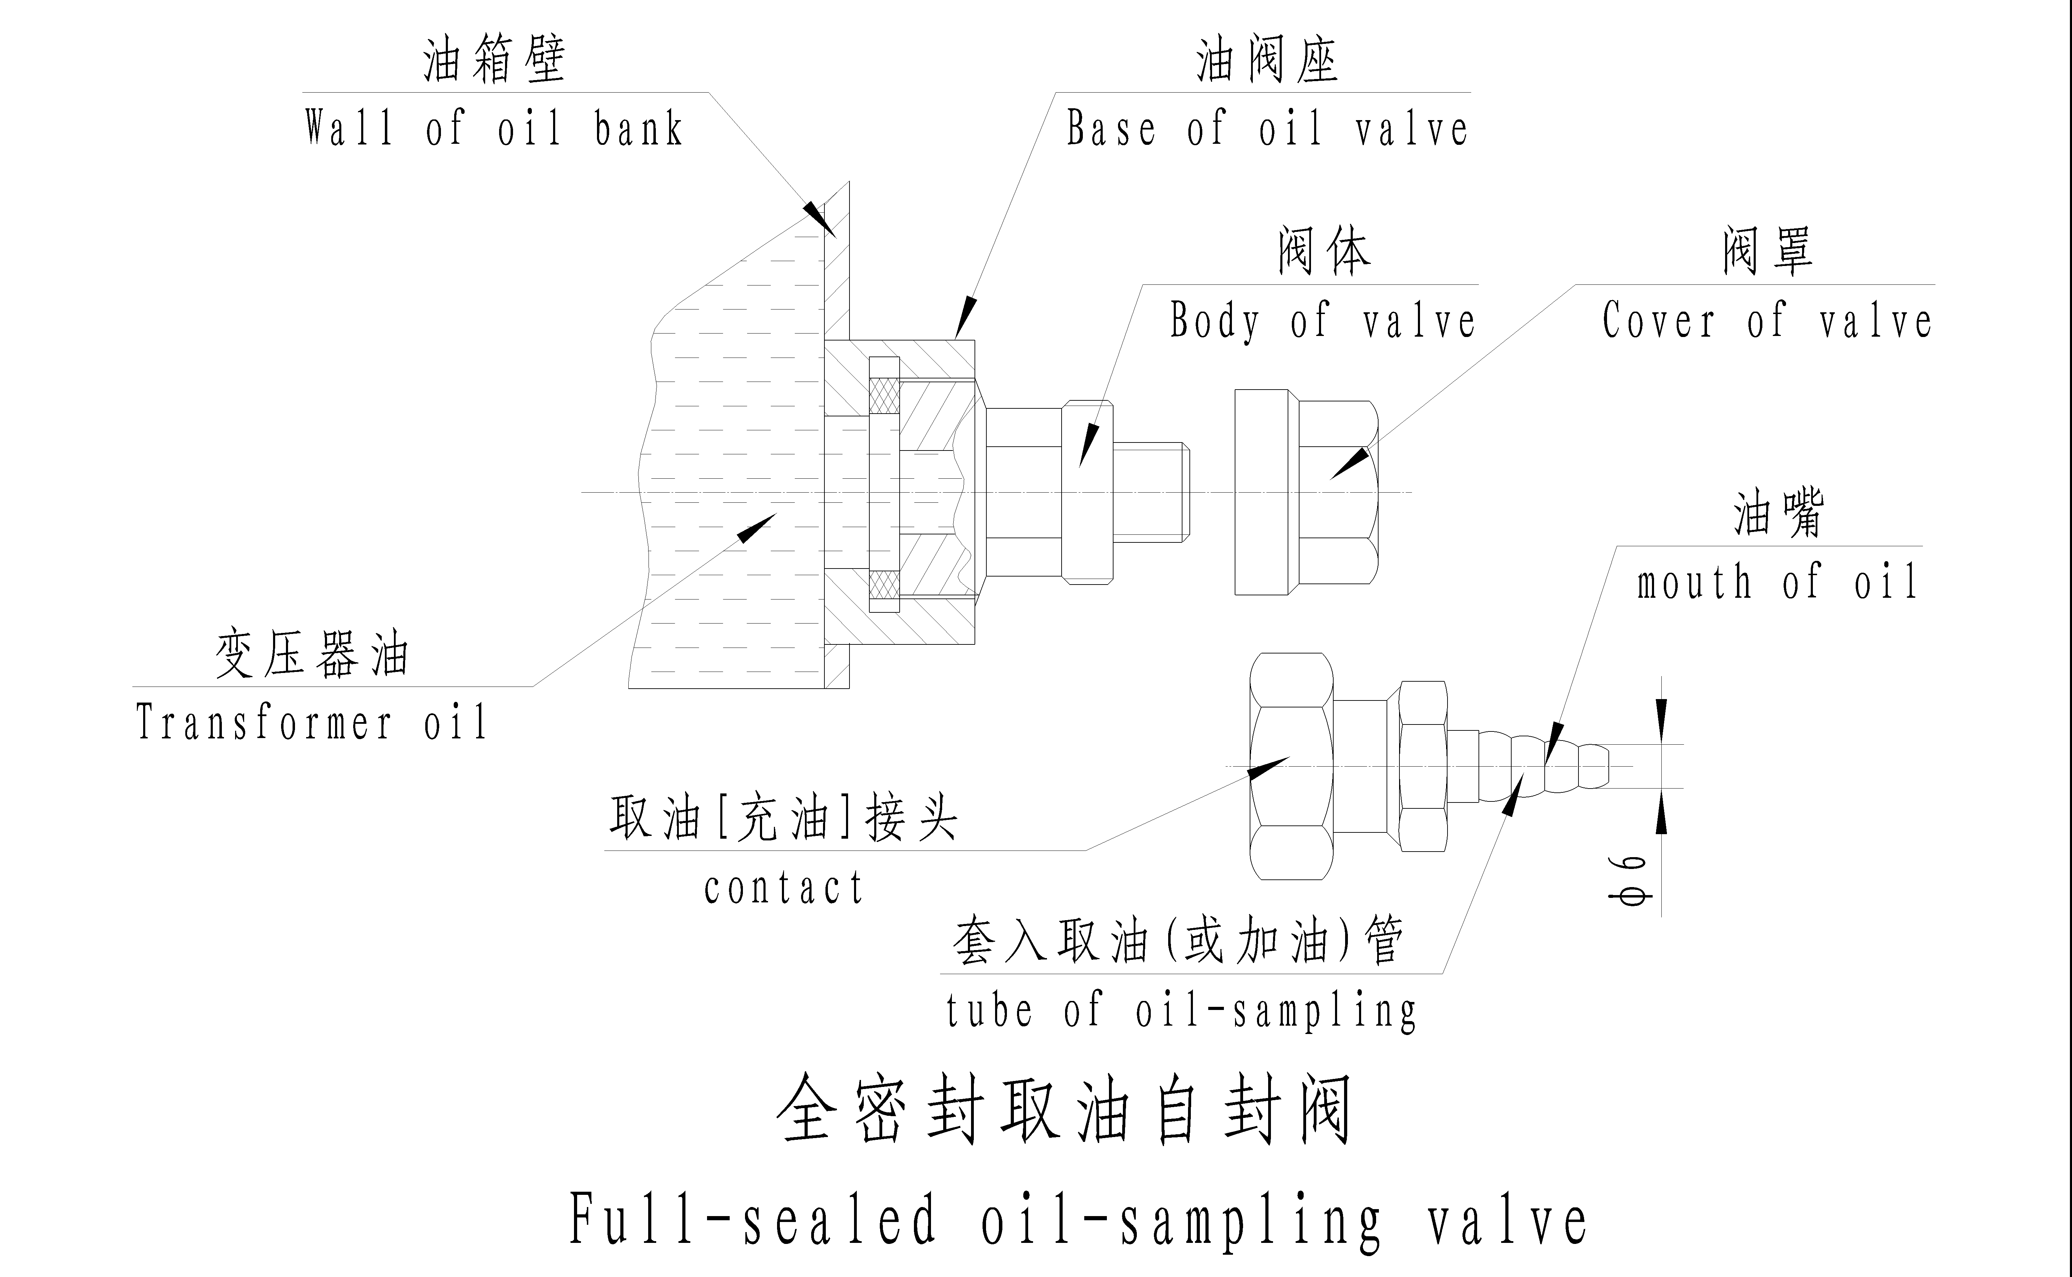

★末屏接地端子（试验抽头）
★End-screen terminal (test tap)

LB7-110W、LB9-220W、LBT9-220W等型电流互感器均设有末屏接地端子（试验抽头），末屏接地端子设在油箱正面的上部，部分型号的末屏接地端子设在油箱背面的上部，末屏对地绝缘电阻不小于10000MΩ。末屏接地端子用于产品局部放电、介质损耗率等试验的测量或在线监测用，产品运行时末屏接地引线要接地，千万不能开路运行！！！将末屏接地外罩旋入安装法兰上的螺纹上，外罩旋入到位即可靠接地，旋松取下外罩既可以进行试验检测或在线监测，试验完毕必须将外罩重新旋入安装法兰上的螺纹上。这种接地端子使用方便，外形美观，密封性能可靠，接地可靠，不易破损，不受外部污秽的影响。用户在安装使用时，请按末屏接地端子示意图所示。
CT with the type of LB7-110W, LB9-220W, LBT9-220W and so on manufactered by our company is fixed with end-screen terminal(test tap), the end-screen terminal is fixed on the upper of right side of products, some end-screen terminals are fixed on the upper of back side of products, insulation resistance of end-screen to ground is not less than 10000MΩ. End-screen is used for measurement of test for partial discharge, dielectric loss rate or on -line observation, end-screen shall be earthed in operation, no open-circuit in operation!!!. The external cover shall be rotated on the thread of flange, which is in place, it is reliably earthed，upon loosing the external cover, test inspection or on-line observation shall be carried out, after test, the external cover shall be re-rotated on the thread of flange. The earthed terminal is convenient for use, and it is with excellent appearance, with reliable sealed performance and with reliable earthed, it is not easy for products to be broken, and effect on external pollution is not suffered. Please according to the requirements of the following figure in assembly and use.
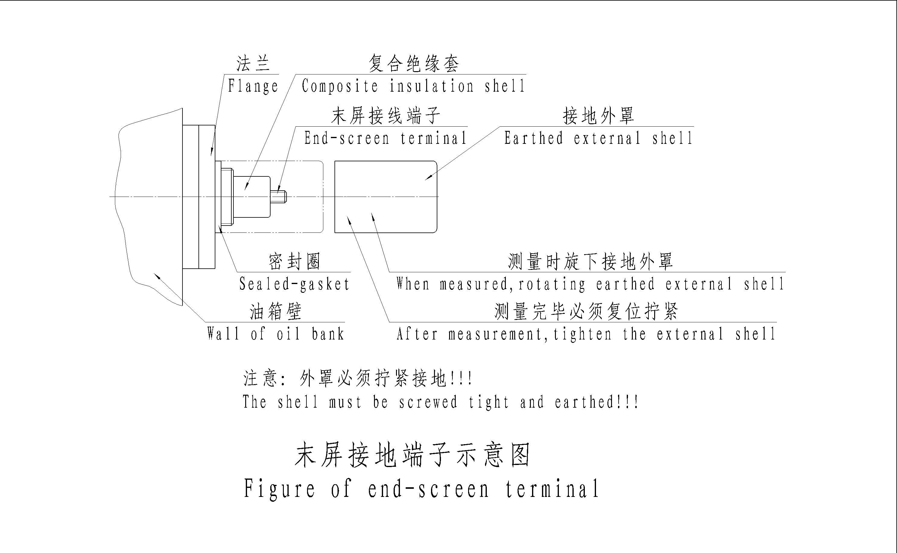
★一次端子实行串并联方法
★Method of parallel connection and serial connection shall be carried out for primary terminal

我公司生产的LB7-110W、LB9-220W、LBT9-220W等型电流互感器一次绕组分成两段，四个出头通过一次出线装置在瓷套上部侧壁引出，可方便地在外部进行串并联换接，以改变电流比。一次端子实行串并联方法见示意图。
Primary windings of CT with the type of LB7-110W, LB9-220W, LBT9-220W and so on manufactured by our company shall be divided into two sections, four taps shall lead from wall of upper porcelain bushing through primary terminal device, so that it is convenient for connection in parallel and in serial, which can change current ratio. Method of parallel connection and serial connection for primary terminal is shown in following drawing.
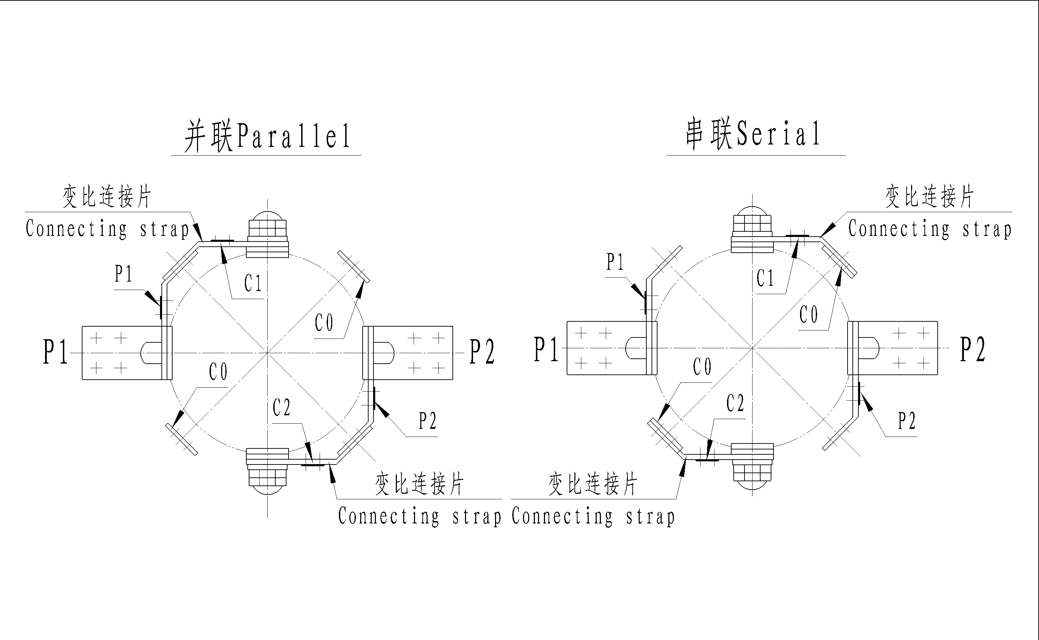
★LCWB-35W, LABN-35W型电流互感器
★LCWB-35W, LABN-35W Current transformer

主要技术参数：
额定电压：35kV
设备最高电压：40.5kV
额定频率：50Hz
额定一次电流：20、30、40、50、75、100、150、200、300、500、400、600、750、800、1000、1200、1250、1500、1600、2000A
额定二次电流：1A或5A
极性：减极性
级次组合：1～4个二次绕组任意组合
额定输出：10～50VA
仪表保安系数（有要求时）：5或10
准确限值系数：15，20
额定绝缘水平：40.5/95/185kV
额定短时热电流：0.065I_{1n}(kA)
额定动稳定电流：0.163I_{1n}(kA)
油重/总重（参考值）：25/130kg
Main technical parameters:
Rated voltage：35kV
Highest system voltage：40.5kV
Rated frequency：50Hz
Rated primary current：20、30、40、50、75、100、150、200、300、400、500、600、750、800、1000、1200、1250、1500、1600、2000A
Rated secondary current：1A or 5A
Polarity：Negative
Class combination：1～4 secondary winding combination at random
Rated output：10～50VA
Instrument security factor (when required)：5 or 10
Accuracy limit factor：15，20
Rated insulation level：40.5/95/185kV
Rated short time thermal current：0.065I_{1n}(kA)
Rated dynamic current：0.163I_{1n}(kA)
Oil weight/Total weight (reference value)：25/130kg

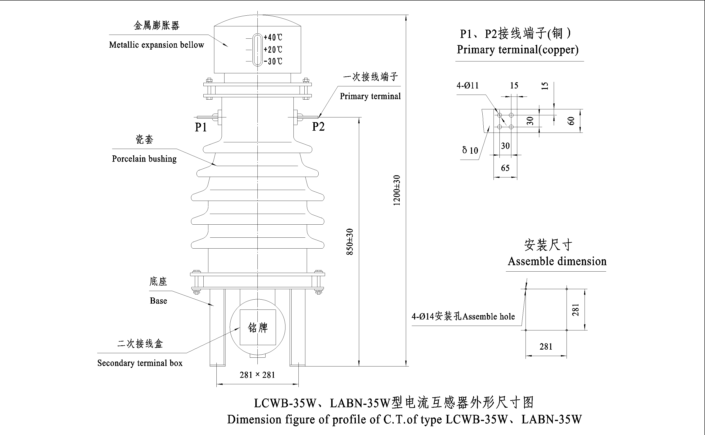

LCWB-35W, LABN-35W型系列电流互感器代表产品
LCWB-35W, LABN-35W Current transformer
产品代号  Drawing Cat. No | 39810WB | 39812WB | 39813WB | 39870AWB | 39898GYWB
额定电流比，A  Rated current ratio，A | 75/5 | 100/5 | 100-200/5 | 600/5 | 2000/5
二次组合  Secondary Combination | 10P/0.5/0.2 | 0.2/0.5/10P | 0.2/10P | 0.2/5P/5P | 10P/10P/0.2
二次出线端子  Secondary terminal | 1S1-1S2  2S1-2S2  3S1-3S2 | 1S1-1S2  2S1-2S2  3S1-3S2 | 1S1-1S2-1S3  2S1-2S2-2S3 | 1S1-1S2  2S1-2S2  3S1-3S2 | 1S1-1S2  2S1-2S2  3S1-3S2
准确级  Accuracy Class | 10P，0.5，0.2 | 10P，0.5，0.2 | 10P，0.2 | 5P，0.2 | 10P，0.2
额定输出，VA  Rated output，VA | 30 | 50 | 满匝Full turn:50 | 40 | 40
额定输出，VA  Rated output，VA | 30 | 50 | 抽头Tap:30 | 40 | 40
准确限值系数  Accuracy limit factor | 15 | 15 | 15 | 20 | 20
仪表保安系数
Instrument security factor
额定短时热电流，kA  Rated short time thermal current，kA | 5 | 6.5 | 7.5-15 | 39 | 40
额定动稳定电，kA  Rated dynamic current，kA | 12.5 | 16.5 | 18.7-37.4 | 97 | 102
★LVB-35W, LVBT-35W倒立式电流互感器
★LVB-35W, LVBT-35W Inverter type current transformer

主要技术参数：
额定电压：35 kV
设备最高电压：40.5kV
额定频率：50Hz
额定一次电流：100、200、300、400、500、600、625、750、800、1000、1200、1250、1500、1600、2000、2500、3000、4000、6000A
额定二次电流：1A或5A
极性：减极性
级次组合：1～6个二次绕组任意组合
额定输出：10～60VA
准确级：5P、10P、TPY、0.5、0.2、0.5S、0.2S、0.1
仪表保安系数（有要求时）：5或10
准确限值系数：10、15、20、25、30、40
额定绝缘水平：40.5/95/185kV
额定短时热电流：31.5、40、50kA
额定动稳定电流：80、100、125 kA
TPY级准确限值条件（也可按用户要求）：
一次时间常数T_{P}：100ms
额定对称短路电流直流分量100%（全偏移）
额定对称短路电流倍数K_{SSC}：10、15、20
额定电阻性负荷R_{b}：5、10、12、15、20
规定的工作循环：C-0.1s-O-0.5s-C-0.1s-O
C-0.1s-O-0.4s-C-0.1s-O
保持准确限值的时间：40ms、50ms、100ms
油重/总重（参考值）：LVB-35W 型：40/300kg；
LVBT-35W 型：115/700kg

Main technical parameters：
Rated voltage：35kV
Highest system voltage：40.5kV
Rated frequency：50Hz
Rated primary current：100、200、300、400、500、600、625、750、800、1000、1200、1250、1500、1600、2000、2500、3000、4000、6000A
Rated secondary current：1A or 5A
Polarity：Negative
Class combination：1～6 secondary winding combination at random
Rated output：10～60VA
Accuracy class：5P、10P、TPY、0.5、0.2、0.5S、0.2S、0.1
Instrument security factor (when required)：5 or 10
Accuracy limit factor：10、15、20、25、30、40
Rated insulation level：40.5/95/185kV
Rated short time thermal current：31.5、40、50kA
Rated dynamic current：80、100、125 kA
Accuracy limit factor of TPY Class (or according to the requirement to consumers).
Primary time constant (T_{P})：100ms
Rated symmetrical short-circuit current direct current is 100%
Rated symmetrical short-circuit current factor (K_{SSC})：10、12、15、20
Rated resistive burden (R_{b}) ：5、10、15、20
Specified duty cycle ：C-0.1s-O-0.5s-C-0.1s-O or C-0.1s-O-0.4s-C-0.1s-O
Permissible time to accuracy limit：40ms、50ms、100ms
Oil weight/Total weight (reference value)：Type LVB-35W：40/300kg；Type LVBT-35W：115/700kg

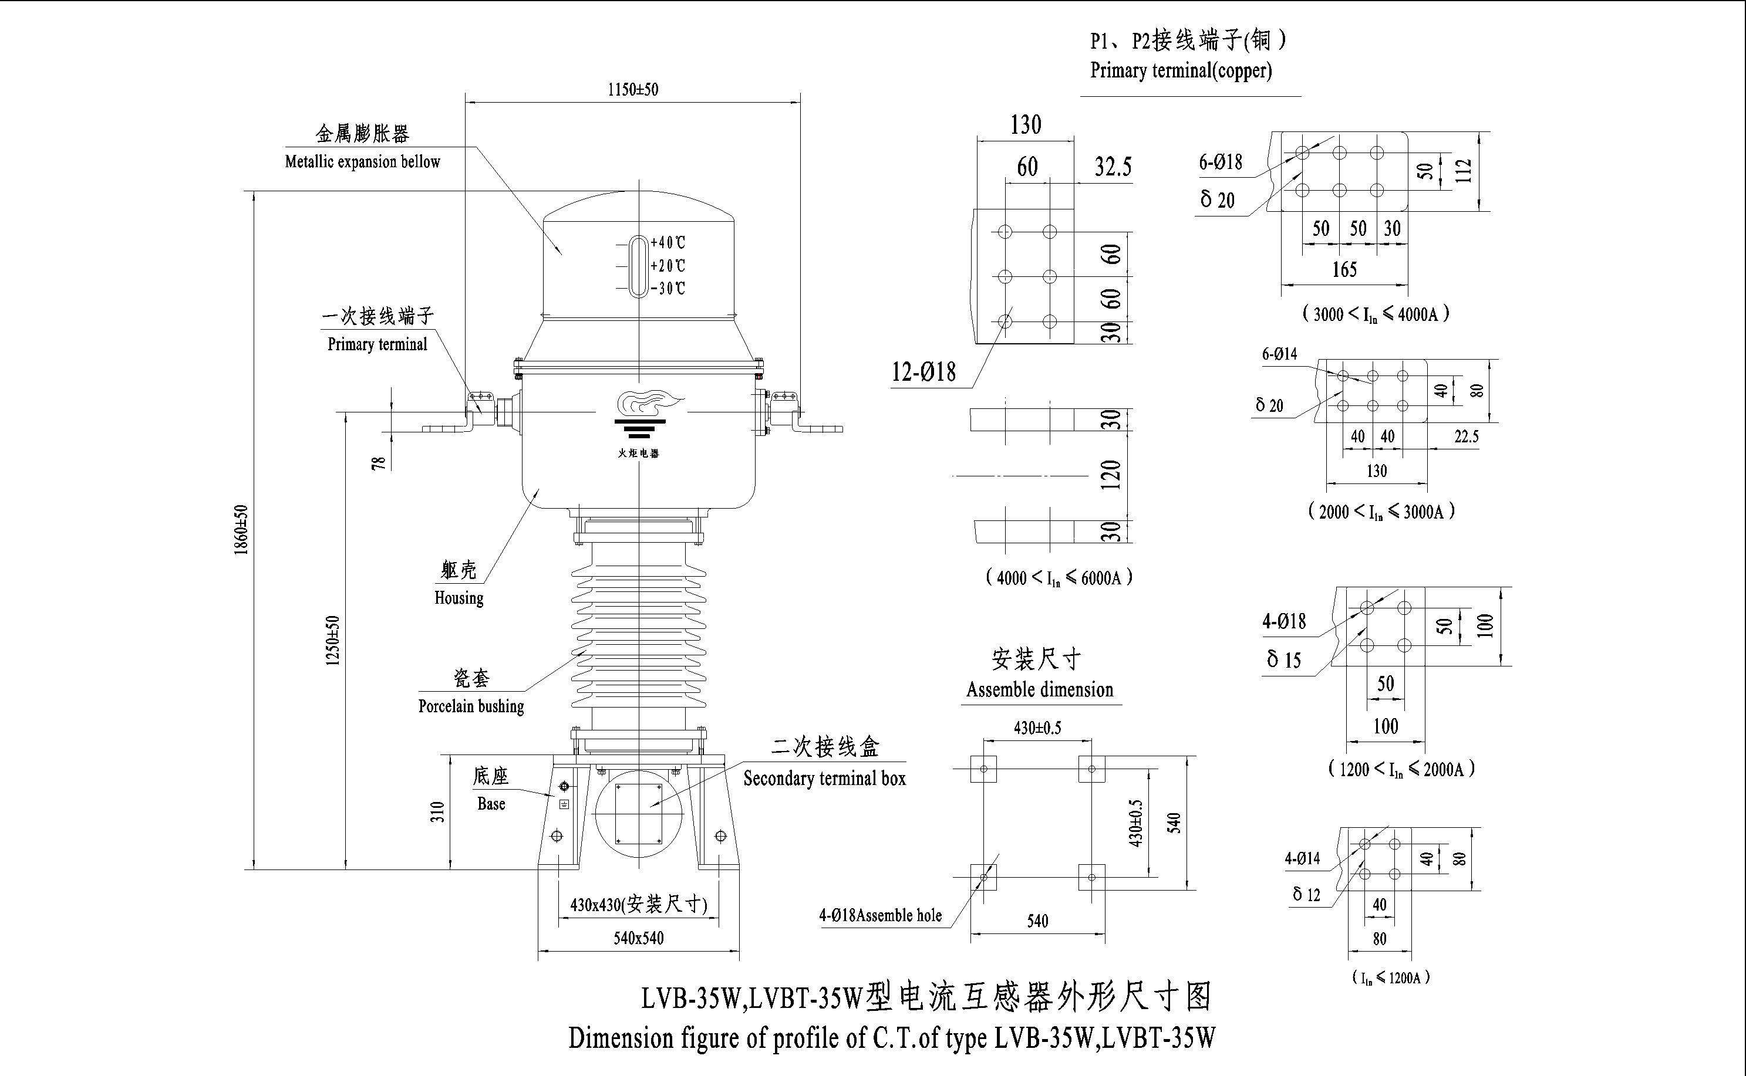

LVB-35W倒立式电流互感器代表产品
LVB-35W Inverter type current transformer
产品代号Drawing Cat. No | 39900WB | 39905GYWB | 39908WB | 39909CWB | 39910WB | 39920WB
额定电流比，A  Rated current ratio，A | 3000-4000/5 | 1000/1 | 4000/5 | 300-1000/5 | 1500-2000/5 | 300/1
二次组合  Secondary Combination | 5P/0.2 | 5P/0.5 | 5P/5P/5P/0.5/0.2S | 10P/10P/0.5/0.2S | 10P/10P/10P/0.5/0.2S | 10P/0.5
二次出线端子  Secondary terminal | 1S1-1S2-1S3  2S1-2S2-2S3 | 1S1-1S2  2S1-2S2 | 1S1-1S2  2S1-2S2  3S1-3S2  4S1-4S2  5S1-5S2 | 1S1-1S2  2S1-2S2  3S1-3S2  4S1-4S2-4S3 | 1S1-1S2  2S1-2S2  3S1-3S2  4S1-4S2-4S3  5S1-5S2-5S3 | 1S1-1S2  2S1-2S2
准确级Accuracy Class | 5P，0.2 | 5P，0.5 | 5P，0.5，0.2S | 10P，0.5，0.2S | 10P，0.5，0.2S | 10P，0.5
额定输出，VA  Rated output，VA | 满匝Full turn:40 | 40 | 50 | 满匝Full turn:50 | 满匝Full turn:50 | 40
额定输出，VA  Rated output，VA | 抽头Tap:30 | 40 | 50 | 抽头Tap:30 | 抽头Tap:30 | 40
准确限值系数  Accuracy limit factor | 满匝Full turn:40 | 40 | 20 | 20 | 20 | 100
准确限值系数  Accuracy limit factor | 抽头Tap:20
仪表保安系数  Instrument security factor | ≤5 | ≤5 |  | ≤10 | ≤10 | ≤5
额定短时热电流，kA  Rated short time thermal current，kA | 50，2s | 40，4s | 30，3s | 50，2s | 50，2s | 40
额定动稳定电，kA  Rated dynamic current，kA | 125 | 100 | 80 | 125 | 125 | 100

LVBT-35W倒立式电流互感器代表产品
LVBT-35W Inverter type current transformer
产品代号Drawing Cat. No |  | 39903GYWB | 39904GYWB | 39906AWB | 39914WB | 39916AWB | 39913WB
额定电流比，A  Rated current ratio，A |  | 4000/1 | 4000/1 | 4000/1 | 6000/1 | 2000-4000/1 | 4000/1
二次组合  Secondary Combination |  | 5P/0.5/5P/  TPY/TPY | 0.5/5P/TPY/TPY | 0.2/5P/TPY/TPY | TPY/TPY/  5P/0.5 | TPY/TPY/  0.2S/0.2S | 0.2S/5P/ TPY/TPY
二次出线端子  Secondary terminal |  | 1S1-1S2  2S1-2S2  3S1-3S2  4S1-4S2  5S1-5S2 | 1S1-1S2  2S1-2S2  3S1-3S2  4S1-4S2 | 1S1-1S2  2S1-2S2  3S1-3S2  4S1-4S2 | 1S1-1S2  2S1-2S2  3S1-3S2  4S1-4S2 | 1S1-1S2  2S1-2S2  3S1-3S2-3S3 | 1S1-1S2  2S1-2S2  3S1-3S2  4S1-4S2
准确级Accuracy Class |  | 5P，TPY，0.5 | 5P，TPY，0.5 | 5P，TPY，0.2 | 5P，TPY，0.5 | TPY，0.2S | 5P，TPY，0.2S
额定输出，VA  Rated output，VA |  | 40 | 40 | 5P：30  0.2：15 | 30 | 40 | 5P：20  0.2S：15
准确限值系数  Accuracy limit factor |  | 20 | 20 | 20 | 20 | / | 10
仪表保安系数  Instrument security factor |  | ≤5 | ≤5 | ≤5 |  | ≤5 | ≤5
额定短时热电流，kA  Rated short time thermal current，kA |  | 50，3s | 50，3s | 50，3s | 50，3s | 40，4s | 40，3s
额定动稳定电，kA  Rated dynamic current，kA |  | 125 | 125 | 125 | 125 | 100 | 100
TPY级准确限制条件 | 对称短路电流倍数K_{SSC}  Symmetrical short-circuit current factor | 10 | 10 | 15 | 10 | 20 | 15
TPY级准确限制条件 | 额定电阻性负荷R_{b}，Ω  Rated resistive burden | 15 | 15 | 10 | 30 | 15 | 10
TPY级准确限制条件 | 一次时间常数T_{P}，ms  Primary time constant | 100 | 100 | 100 | 100 | 100 | 100
TPY级准确限制条件 | 规定的工作循环  Specified duty cycle | C-0.1s-O-0.3s-  C-0.04s-O | C-0.1s-O-0.3s-  C-0.04s-O | C-0.1s-O-0.3s-  C-0.05s-O | C-0.1(0.04)s-O | C-0.1s-O-0.3s-  C-0.05(0.04)s-O | C-0.1s-O-0.3s-  C-0.05s-O
TPY级准确限制条件 | 剩磁系数  Remanence factor | ≤0.1 | ≤0.1 | ≤0.1 | ≤0.1 | ≤0.1 | ≤0.1
TPY级准确限制条件 | 对称短路电流直流分量  Rated symmetrical short-circuit current direct current | 100% | 100% | 100% | 100% | 100% | 100%
★LB7-110W型电流互感器
★LB7-110W current transformer

主要技术参数：
额定电压：110kV
设备最高电压：126kV
额定频率：50Hz
额定一次电流：50、75、100、150、200、300、400、500、600、625、750、800、1000、1200、1250、1500、1600、2000、2500、3000A
额定二次电流：1A或5A
极性：减极性
级次组合：1～6个二次绕组任意组合
额定输出：10～60VA
准确级：保护级为5P、10P；测量级为0.5、0.2、0.5S、0.2S、0.1
仪表保安系数（有要求时）：5或10
准确限值系数：10、15、20、25、30、40
额定绝缘水平：126/185（230）/450（550）kV
油重/总重（参考值）：210/750kg
Main technical parameters
Rated voltage：110kV
Highest system voltage：126kV
Rated frequency：50Hz
Rated primary current：50、75、100、150、200、300、400、500、600、625、750、800、1000、1200、1250、1500、1600、2000、2500、3000A
Rated secondary current：1A or 5A
Polarity：Negative
Class combination：1～6 secondary winding combination at random
Rated output：10～60VA
Accuracy class：Protection class is 5P，10P；Measurement class is 0.5、0.2、0.5S、0.2S
Instrument security factor (when required)：5 or 10
Accuracy limit factor：10、15、20、25、30、40
Rated insulation level：126/185（230）/450（550）kV
Oil weight/Total weight (reference value)：210/750kg

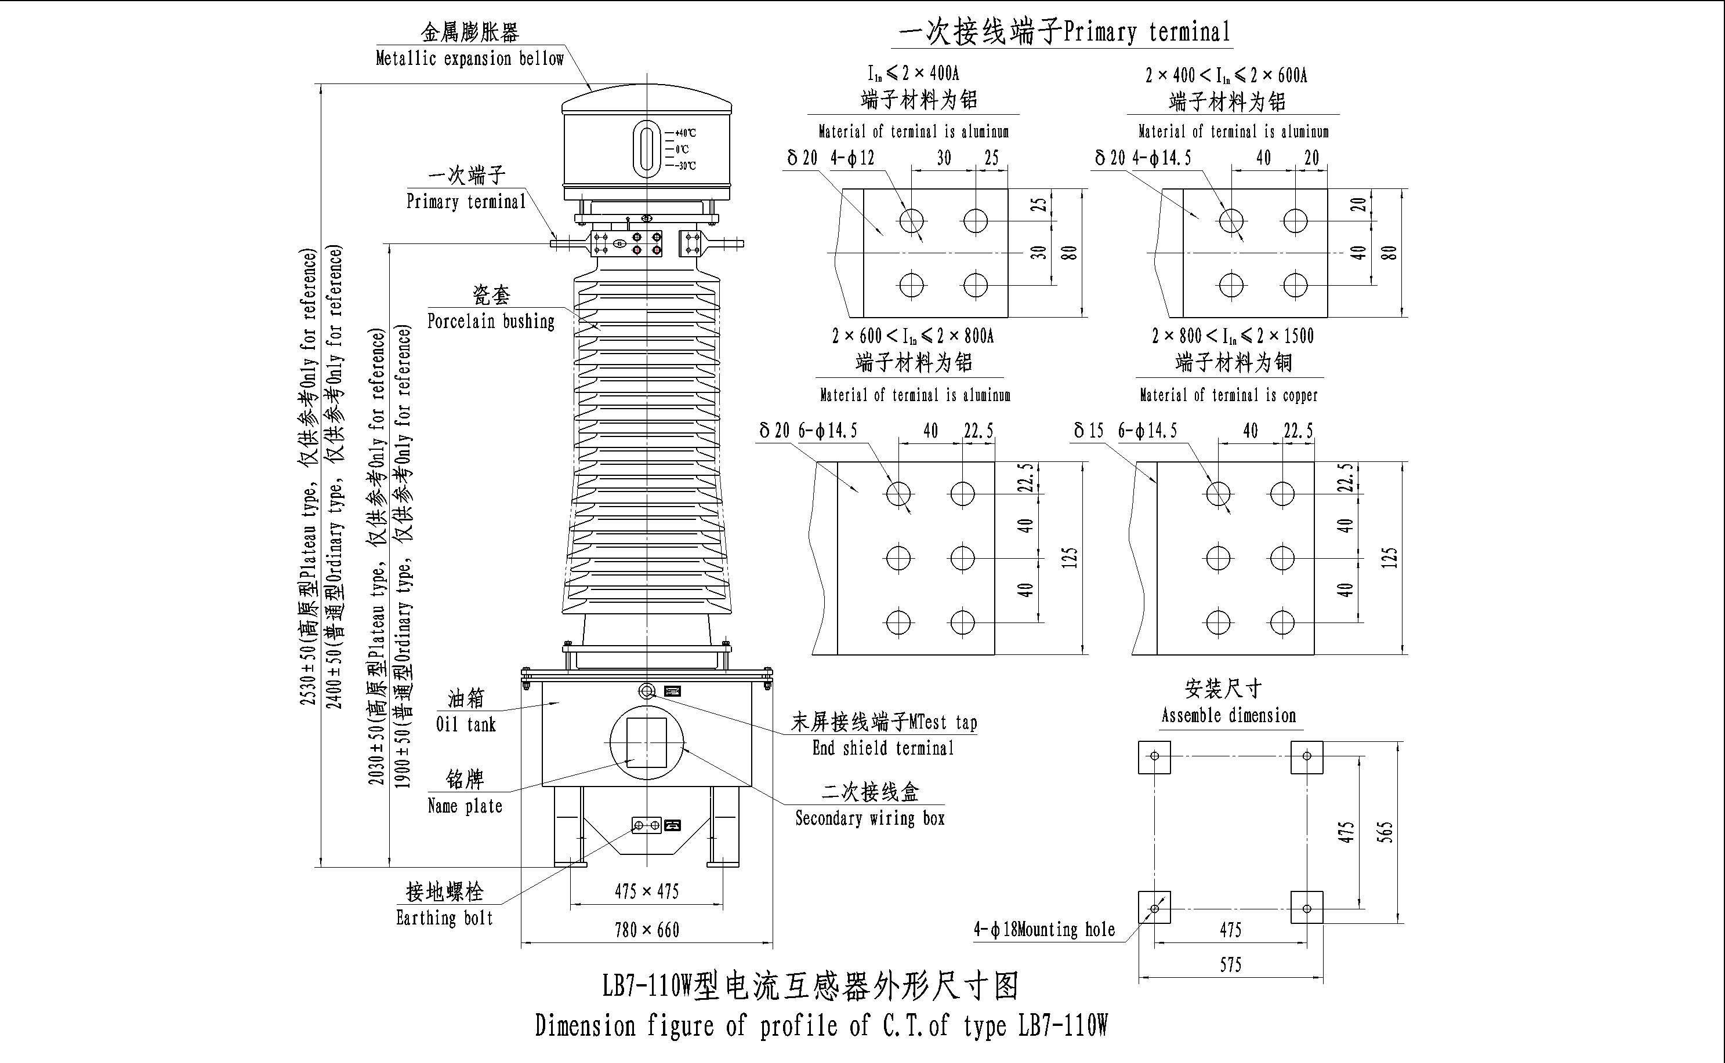

LB7-110W电流互感器代表产品
LB7-110W current transformer
产品代号  Drawing Cat. No | 39595AWB | 39591EWB | 39594CWB | 39591DWB | 39581DWB | 39583CWB
额定电流比，A  Rated current ratio，A | 50/1 | 2×50/5 | 75/5 | 2×75/5 | 2×100/5 | 200/5
二次组合  Secondary Combination | 5P/5P/0.2S/0.5/  5P/5P/ | 0.5/0.2S/10P/  10P/10P | 10P/10P/10P0.2 | 10P/10P/10P/0.2 | 10P/10P/0.5/0.2S | 5P/5P/5P/0.5/0.2S
二次出线端子  Secondary terminal | 1S1-1S2  2S1-2S2  3S1-3S2  4S1-4S2  5S1-5S2  6S1-6S2 | 1S1-1S2  2S1-2S2  3S1-3S2  4S1-4S2  5S1-5S2 | 1S1-1S2  2S1-2S2  3S1-3S2  4S1-4S2 | 1S1-1S2  2S1-2S2  3S1-3S2  4S1-4S2 | 1S1-1S2  2S1-2S2  3S1-3S2  4S1-4S2 | 1S1-1S2  2S1-2S2  3S1-3S2  4S1-4S2  5S1-5S2
准确级  Accuracy Class | 5P，0.2S，0.5 | 10P，0.2S，0.5 | 10P，0.2 | 10P，0.2 | 10P，0.2S，0.5 | 5P，0.2S，0.5
额定输出，VA  Rated output，VA | 20 | 10P：50  0.5、0.2S：40 | 20 | 30 | 50 | 30
准确限值系数  Accuracy limit factor | 20 | 15 | 15 | 15 | 30 | 20
仪表保安系数  Instrument security factor |  |  |  |  | ≤10 | ≤5
额定短时热电流，kA  Rated short time thermal current，kA | 31.5 | 25-31.5，3s | 15，3s | 21 | 40，3s | 31.5，4s
额定动稳定电，kA  Rated dynamic current，kA | 80 | 63-80 | 40 | 54 | 100 | 80

产品代号  Drawing Cat. No | 39573CGYWB | 39571CWB | 39570CWB | 39568EGYWB | 39543FWB |  | 39545FWB
额定电流比，A  Rated current ratio，A | 150/5 | 150/5 | 2×150/5 | 2×150/5  抽头Tap:2×75/5 | 2×200/5  抽头Tap:2×100/5 |  | 2×200/5
二次组合  Secondary Combination | 10P/10P/10P/0.5 | 0.2S/5P/10P/5P | 5P/5P/5P/ 0.5/0.2S | 0.2S /0.5/  10P/10P/10P | 0.2S /0.5/  10P/10P/10P/10P |  | 0.2S/0.5/5P/5P
二次出线端子  Secondary terminal | 1S1-1S2  2S1-2S2  3S1-3S2  4S1-4S2 | 1S1-1S2  2S1-2S2  3S1-3S2  4S1-4S2 | 1S1-1S2  2S1-2S2  3S1-3S2  4S1-4S2  5S1-5S2 | 1S1-1S2-1S3  2S1-2S2-2S3  3S1-3S2  4S1-4S2  5S1-5S2 | 1S1-1S2-1S3  2S1-2S2-2S3  3S1-3S2-3S3  4S1-4S2-4S3  5S1-5S2-5S3  6S1-6S2-6S3 |  | 1S1-1S2  2S1-2S2  3S1-3S2  4S1-4S2
准确级  Accuracy Class | 10P，0.5 | 10P，5P ，0.2S | 5P，0.2S，0.5 | 10P，0.2S，0.5 | 10P，0.2S，0.5 |  | 5P，0.2S，0.5
额定输出，VA  Rated output，VA | 40 | 30 | 50 | 满匝Full turn:50 | 满匝  Full turn | 10P:50 | 50
 |  |  |  |  |  | 0.2S,0.5:40 | 50
 |  |  |  | 抽头Tap:40 | 抽头Tap | 10P:25 | 50
 |  |  |  |  |  | 0.2S,0.5:20 | 50
准确限值系数  Accuracy limit factor | 20 | 10P：15  5P：20 | 30 | 20 | 30 |  | 20
仪表保安系数  Instrument security factor | ≤5 |  |  | ≤5 |  |  | ≤5
额定短时热电流，kA  Rated short time thermal current，kA | 45 | 45 | 40，3s | 40，3s | 25-31.5，3s |  | 31.5-45，3s
额定动稳定电，kA  Rated dynamic current，kA | 115 | 115 | 100 | 100 | 63-80 |  | 80-125

产品代号  Drawing Cat. No | 39356AWB | 39353QGYWB | 39383AWB | 39399IWB | 39397AWB | 39551QWB
额定电流比，A  Rated current ratio，A | 300/1 | 2×300/5  抽头Tap:2×150/5 | 5P:2×300/1  0.2S ,0.2:2×150/1  抽头Tap:2×75/1 | 2×300/5  抽头Tap:2×150/5 | 2×400/1 | 2×400/5
二次组合  Secondary Combination | 5P/5P/0.2S/0.5/  5P/5P/ | 5P/5P/5P/5P  /0.5/0.2 | 0.2S /0.2  /5P/5P/5P/5P | 10P/10P/10P/  0.5/0.2S | 5P/5P/5P  /0.5S/0.2S | 5P/5P/5P/5P  /0.5/0.2S
二次出线端子  Secondary terminal | 1S1-1S2  2S1-2S2  3S1-3S2  4S1-4S2  5S1-5S2  6S1-6S2 | 1S1-1S2-1S3  2S1-2S2-2S3  3S1-3S2-3S3  4S1-4S2-4S3  5S1-5S2-5S3  6S1-6S2-6S3 | 1S1-1S2-1S3  2S1-2S2-2S3  3S1-3S2  4S1-4S2  5S1-5S2  6S1-6S2 | 1S1-1S2-1S3  2S1-2S2-2S3  3S1-3S2-3S3  4S1-4S2-4S3  5S1-5S2-5S3 | 1S1-1S2  2S1-2S2  3S1-3S2  4S1-4S2  5S1-5S2 | 1S1-1S2  2S1-2S2  3S1-3S2  4S1-4S2  5S1-5S2  6S1-6S2
准确级  Accuracy Class | 5P，0.2S，0.5 | 5P，0.2，0.5 | 5P，0.2S，0.2 | 5P，0.2S，0.5 | 5P，0.2S，0.5S | 5P，0.2S，0.5
额定输出，VA  Rated output，VA | 30 | 30 | 5P:10 | 满匝Full turn:50 | 30 | 50
额定输出，VA  Rated output，VA | 30 | 30 | 0.2S,0.2:5 | 抽头Tap:30 | 30 | 50
准确限值系数  Accuracy limit factor | 20 | 20 | 40 | 20 | 20 | 20
仪表保安系数  Instrument security factor |  | ≤5 | ≤5 | ≤5 | ≤5 | ≤10
额定短时热电流，kA  Rated short time thermal current，kA | 31.5 | 31-45 | 40，3s | 31.5，3s | 31.5-45，3s | 31.5-45
额定动稳定电，kA  Rated dynamic current，kA | 80 | 80-115 | 100 | 80 | 80-115 | 80-125

产品代号  Drawing Cat. No | 39553UWB | 39552UWB | 39554UWB | 39400AWB | 39418AWB | 39426DWB
额定电流比，A  Rated current ratio，A | 2×400/1  抽头Tap:  2×200/1 | 2×400/5 | 2×500/5 | 600/1 | 600-1200/1 | 5P:2×600/5  0.2S ,0.2:2×300/5  抽头Tap:2×150/5
二次组合  Secondary Combination | 5P/5P/5P/5P/0.5/0.2S | 10P/10P/10P  /0.5/0.2S | 5P/5P/5P/  0.5/0.2S | 5P/5P/0.2S/0.5/  5P/5P | 5P/5P/5P/5P  /0.2/0.2S | 5P/5P/5P/5P  /0.2/0.2S
二次出线端子  Secondary terminal | 1S1-1S2-1S3  2S1-2S2-2S3  3S1-3S2-3S3  4S1-4S2-4S3  5S1-5S2-5S3  6S1-6S2-6S3 | 1S1-1S2  2S1-2S2  3S1-3S2  4S1-4S2  5S1-5S2 | 1S1-1S2  2S1-2S2  3S1-3S2  4S1-4S2  5S1-5S2 | 1S1-1S2  2S1-2S2  3S1-3S2  4S1-4S2  5S1-5S2  6S1-6S2 | 1S1-1S2-1S3  2S1-2S2-2S3  3S1-3S2-3S3  4S1-4S2-4S3  5S1-5S2-5S3  6S1-6S2-6S3 | 1S1-1S2  2S1-2S2  3S1-3S2  4S1-4S2  5S1-5S2-5S3  6S1-6S2-6S3
准确级  Accuracy Class | 5P，0.2S，0.5 | 10P，0.2S，0.5 | 5P，0.2S，0.5 | 5P，0.2S，0.5 | 5P，0.2S，0.2 | 5P，0.2S，0.2
额定输出，VA  Rated output，VA | 满匝Full turn:30 | 50 | 30 | 30 | 满匝Full turn:30 | 5P | 50
额定输出，VA  Rated output，VA | 抽头Tap:20 | 50 | 30 | 30 | 抽头Tap:15 | 0.2  0.2S | 满匝Full turn:50
 |  |  |  |  |  |  | 抽头Tap:30
准确限值系数  Accuracy limit factor | 30 | 20 | 20 | 20 | 40 | 30
仪表保安系数  Instrument security factor |  | ≤5 | ≤5 |  | ≤10
额定短时热电流，kA  Rated short time thermal current，kA | 31.5-45 | 50 | 31.5，4s | 31.5 | 45，3s | 45
额定动稳定电，kA  Rated dynamic current，kA | 80-115 | 125 | 80 | 80 | 80-115 | 115

产品代号  Drawing Cat. No | 39427EWB | 39430AWB |  |  | 39435KWB |  | 39443EWB |  | 39450EWB |  |  | 39453DWB
额定电流比，A  Rated current ratio，A | 2×600/5  抽头Tap:  2×300/5 | 2×600/1  抽头Tap:  2×300/1  抽头Tap:  2×150/1 |  |  | 2×600/5  抽头Tap:  2×300/5 |  | 2×600/5  抽头Tap:  2×300/5 |  | 2×750/5  抽头Tap:  2×400/5 |  |  | 2×750/5  抽头Tap:  2×375/5
二次组合  Secondary Combination | 5P/5P/5P/5P  /0.5/0.2S | 10P/10P/10P  /0.5/0.2S |  |  | 5P/5P/5P  /0.5/0.2S |  | 5P/5P/5P/5P  /0.5/0.2S |  | 5P/5P/5P  /0.5/0.2S |  |  | 5P/5P/5P  /0.5/0.2S
二次出线端子  Secondary terminal | 1S1-1S2-1S3  2S1-2S2-2S3  3S1-3S2-3S3  4S1-4S2-4S3  5S1-5S2-5S3  6S1-6S2-6S3 | 1S1-1S2-1S3  2S1-2S2-2S3  3S1-3S2-3S3  4S1-4S2-4S3  5S1-5S2-5S3-5S4 |  |  | 1S1-1S2-1S3  2S1-2S2-2S3  3S1-3S2-3S3  4S1-4S2-4S3  5S1-5S2-5S3 |  | 1S1-1S2  2S1-2S2  3S1-3S2  4S1-4S2  5S1-5S2  6S1-6S2-6S3 |  | 1S1-1S2  2S1-2S2  3S1-3S2  4S1-4S2-4S3  5S1-5S2-5S3 |  |  | 1S1-1S2  2S1-2S2  3S1-3S2  4S1-4S2-4S3  5S1-5S2-5S3
准确级  Accuracy Class | 5P，0.2S，0.5 | 10P，0.2S，0.5 |  |  | 5P，0.2S，0.5 |  | 5P，0.2S，0.5 |  | 5P，0.2S，0.5 |  |  | 5P，0.2S，0.5
额定输出，VA  Rated output，VA | 满匝  Full turn:50 | 满匝  Full turn:30 |  |  | 满匝  Full turn:50 |  | 满匝  Full turn:50 |  | 5P |  | 60 | 5P |  | 50
额定输出，VA  Rated output，VA | 抽头Tap:30 | 抽头  Tap: |  | 15 | 抽头Tap:30 |  | 抽头Tap:30 |  | 0.5  0.2S |  | 满匝Full turn:50 | 0.2  0.2S |  | 满匝Full turn:50
额定输出，VA  Rated output，VA | 抽头Tap:30 |  |  | 10 |  |  |  |  |  |  | 抽头Tap:40 |  |  | 抽头Tap:30
准确限值系数  Accuracy limit factor | 30 | 15 |  |  | 30 |  | 40 |  | 20 |  |  | 20
仪表保安系数  Instrument security factor | ≤5 | ≤10 |  |  | ≤5 |  |  |  |  |  |  | ≤5
额定短时热电流，kA  Rated short time thermal current，kA | 40，4s | 31.5 |  |  | 31.5-45，3s |  | 45，3s |  | 40 |  |  | 31.5-45
额定动稳定电，kA  Rated dynamic current，kA | 115 | 80 |  |  | 80-115 |  | 115 |  | 100 |  |  | 80-115
产品代号  Drawing Cat. No | 39457AWB |  | 39464AWB |  |  | 39472AWB |  | 39466JWB |  | 39466QGYWB |  |  | 39465DDWB
额定电流比，A  Rated current ratio，A | 2×750/1 |  | 2×800/1  抽头Tap:2×400/1 |  |  | 2×800/1  抽头Tap:  2×400/1 |  | 2×1000/5  抽头Tap:  2×500/5 |  | 2×1000/5  抽头Tap:  2×600/5 |  |  | 2×1000/5
二次组合  Secondary Combination | 5P/5P/5P  /0.5/0.2S |  | 0.2S/0.5/  5P/5P/5P/5P |  |  | 5P/5P/5P/5P  /0.5/0.2S |  | 5P/5P/5P  /0.5/0.2S |  | 5P/5P/5P/  0.5S/0.2S |  |  | 5P/5P/0.1/0.2S
二次出线端子  Secondary terminal | 1S1-1S2  2S1-2S2  3S1-3S2  4S1-4S2  5S1-5S2 |  | 1S1-1S2-1S3  2S1-2S2-2S3  3S1-3S2  4S1-4S2  5S1-5S2  6S1-6S2 |  |  | 1S1-1S2-1S3  2S1-2S2-2S3  3S1-3S2-3S3  4S1-4S2-4S3  5S1-5S2-5S3  6S1-6S2-6S3 |  | 1S1-1S2-1S3  2S1-2S2-2S3  3S1-3S2-3S3  4S1-4S2-4S3  5S1-5S2-5S3 |  | 1S1-1S2  2S1-2S2  3S1-3S2  4S1-4S2-4S3  5S1-5S2-5S3 |  |  | 1S1-1S2  2S1-2S2  3S1-3S2  4S1-4S2
准确级  Accuracy Class | 5P，0.2S，0.5 |  | 5P，0.2S，0.5 |  |  | 5P，0.2S，0.5 |  | 5P，0.2S，0.5 |  | 5P，0.2S，0.5S |  |  | 5P，0.2S，0.1
额定输出，VA  Rated output，VA | 50 |  | 5P,0.5:50 |  |  | 30 |  | 5P:40 |  | 30 |  |  | 50
额定输出，VA  Rated output，VA |  |  | 0.2S:30 |  |  |  |  | 0.5、0.2S:30
准确限值系数  Accuracy limit factor | 20 |  | 30 |  |  | 30 |  | 20 |  | 30 |  |  | 20
仪表保安系数  Instrument security factor | ≤5 |  |  |  |  |  |  |  |  | ≤5 |  |  | ≤5
额定短时热电流，kA  Rated short time thermal  current，kA | 31.5-45 |  | 45,3s |  |  | 40，3s |  | 63，3s |  | 40，3s |  |  | 60-63，3s
额定动稳定电，kA  Rated dynamic current，kA | 80-115 |  | 115 |  |  | 100 |  | 160 |  | 100 |  |  | 125-160

产品代号  Drawing Cat. No | 39463DAWB | 39463WB | 39469D WB |  | 39468DWB | 39468FWB |  | 39468WB
额定电流比，A  Rated current ratio，A | 2×1200/5  抽头Tap:  2×600/5 | 2×1200/5  抽头Tap:  2×600/5 | 2×1250/5  抽头Tap:  2×625/5 |  | 2×1500/5 | 2×1500/5  抽头Tap:  2×750/5 |  | 2×1500/5  抽头Tap:  2×750/5
二次组合  Secondary Combination | 5P/5P/5P  /0.5/0.2S | 5P/5P/5P/  0.5S/0.2S | 0.2S/0.5/  5P/5P/5P |  | 5P/5P/5P  /0.5S | 0.2S/0.5/  5P/5P/5P/5P |  | 10P/10P/10P  /0.5S/0.2S
二次出线端子  Secondary terminal | 1S1-1S2  2S1-2S2  3S1-3S2  4S1-4S2-4S3  5S1-5S2-5S3 | 1S1-1S2-1S3  2S1-2S2-2S3  3S1-3S2-3S3  4S1-4S2-4S3  5S1-5S2-5S3 | 1S1-1S2-1S3  2S1-2S2-2S3  3S1-3S2  4S1-4S2  5S1-5S2 |  | 1S1-1S2  2S1-2S2  3S1-3S2  4S1-4S2 | 1S1-1S2-1S3  2S1-2S2-2S3  3S1-3S2  4S1-4S2  5S1-5S2  6S1-6S2 |  | 1S1-1S2  2S1-2S2  3S1-3S2  4S1-4S2-4S3  5S1-5S2-5S3
准确级  Accuracy Class | 5P，0.2S，0.5 | 5P，0.2S，0.5S | 5P，0.2S，0.5 |  | 10P，0.5S | 5P，0.2S，0.5 |  | 10P，0.2S，0.5
额定输出，VA  Rated output，VA | 满匝  Full turn:50 | 5P,0.5:50 | 5P:50 |  | 5P:60 | 5P:50 |  | 满匝  Full turn:50
额定输出，VA  Rated output，VA | 抽头Tap:40 | 0.2S:40 | 0.5  0.2S | 满匝Full turn:40 | 0.5S:30 | 0.5  0.2S | 满匝  Full turn:40 | 抽头Tap:35
 |  |  |  | 抽头Tap:20 | 0.5S:30 | 0.5  0.2S | 抽头Tap:20 | 抽头Tap:35
准确限值系数  Accuracy limit factor | 40 | 30 | 20 |  | 30 | 20 |  | 25
仪表保安系数  Instrument security factor | ≤10 |  | ≤5 |  |  | ≤5 |  | ≤20
额定短时热电流，kA  Rated short time thermal  current，kA | 40，3s | 40-80，3s | 31.5 |  | 31.5，2s | 31.5 |  | 40-70
额定动稳定电，kA  Rated dynamic current，kA | 100 | 100-200 | 80 |  | 80 | 80 |  | 100

★LB9-220W型电流互感器
★LB9-220W current transformer
主要技术参数：
额定电压：220kV
设备最高电压：252kV
额定频率：50Hz
额定一次电流：50、75、100、150、200、300、400、500、600、625、750、800、1000、1200、1250、1500、1600、2000、2500、3000A
额定二次电流：1A或5A
极性：减极性
级次组合：1～8个二次绕组任意组合
额定输出：10～60VA
准确级：保护级为5P、10P；
测量级为0.5、0.2、0.5S、0.2S、0.1
仪表保安系数（有要求时）：5或10
准确限值系数：10、15、20、25、30、40
额定绝缘水平：252/395（460）/950（1050）kV
油重/总重（参考值）：330/1200kg
Main technical parameters：
Rated voltage：220kV
Highest system voltage：252kV
Rated frequency：50Hz
Rated primary current：50、75、100、150、200、300、400、500、600、625、750、800、1000、1200、1250、1500、1600、2000、2500、3000A
Rated secondary current：1A or 5A
Polarity：Negative
Class combination：1～8 secondary winding combination at random
Rated output：10～60VA
Accuracy class：Protection class is 5P，10P；Measurement class is 0.5、0.2、0.5S、0.2S、0.1
Instrument security factor (when required)：5 or 10
Accuracy limit factor：10、15、20、25、30、40
Rated insulation level：252/395(460)/950(1050)kV
Oil weight/Total weight (reference value)：330/1200kg
Dimension：3500×820×660mm
Packing dimension：4000×880×1000mm

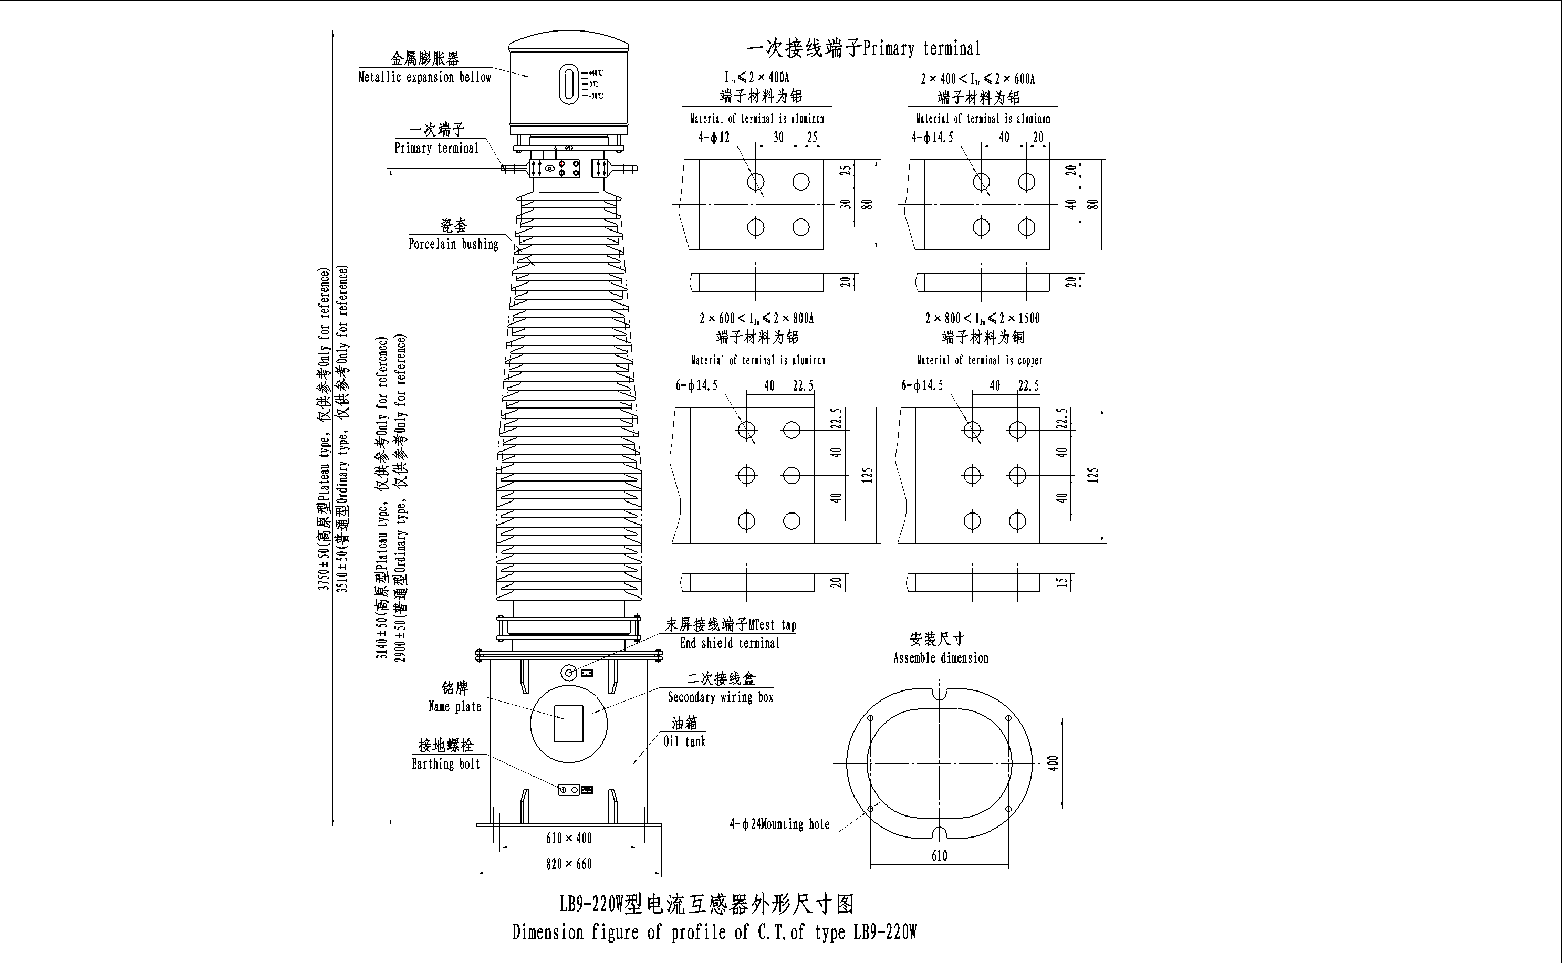

LB9-220W电流互感器代表产品
LB9-220W current transformer
产品代号  Drawing Cat. No | 39061AGYWB | 39703EGYWB | 39707DGYWB | 39700DWB | 39709AGYWB | 39237AGYWB | 39708DWB
额定电流比，A  Rated current ratio，A | 3S～6S：2×100/1  1S、2S：2×300/1 | 2×200/5 | 200-400/5 | 2×300/5 | 2×300/1 | 2×400/1 | 500/5
二次组合  Secondary Combination | 5P/5P/5P/5P  /0.5/0.2S | 5P/5P/5P/5P  /5P/0.2S | 5P/5P/5P/5P/5P  /0.5/0.2S | 0.2S/0.2/5P/  5P/5P/5P | 5P/5P/5P/5P  /0.5/0.2 | 5P/5P/5P/5P/5P  /5P /0.5S/0.2S | 5P/5P/5P/5P  /0.5/0.2S
二次出线端子  Secondary terminal | 1S1-1S2  2S1-2S2  3S1-3S2  4S1-4S2  5S1-5S2  6S1-6S2 | 1S1-1S2  2S1-2S2  3S1-3S2  4S1-4S2  5S1-5S2  6S1-6S2 | 1S1-1S2-1S3  2S1-2S2-2S3  3S1-3S2-3S3  4S1-4S2-4S3  5S1-5S2-5S3  6S1-6S2-6S3  7S1-7S2-7S3 | 1S1-1S2  2S1-2S2  3S1-3S2  4S1-4S2  5S1-5S2  6S1-6S2 | 1S1-1S2  2S1-2S2  3S1-3S2  4S1-4S2  5S1-5S2  6S1-6S2 | 1S1-1S2  2S1-2S2  3S1-3S2  4S1-4S2  5S1-5S2  6S1-6S2  7S1-7S2  8S1-8S2 | 1S1-1S2  2S1-2S2  3S1-3S2  4S1-4S2  5S1-5S2  6S1-6S2
准确级  Accuracy Class | 5P，0.2S，0.5 | 5P，0.2S | 5P，0.2S，0.5 | 5P，0.2S，0.2 | 5P，0.2，0.5 | 5P，0.2S，0.5S | 5P，0.2S，0.5
额定输出，VA  Rated output，VA | 3S～6S：20  1S、2S：30 | 5P：20  0.2S：30 | 满匝Full turn:40 | 50 | 5P：40  0.2，0.5：25 | 30 | 30
额定输出，VA  Rated output，VA | 3S～6S：20  1S、2S：30 | 5P：20  0.2S：30 | 抽头Tap:20
准确限值系数  Accuracy limit factor | 40 | 20 | 20 | 20 | 40 | 30 | 20
仪表保安系数  Instrument security factor | ≤10 | ≤5 | ≤5 | ≤5 | ≤10 | ≤5 | ≤5
额定短时热电流，kA  Rated short time thermal current，kA | 42，3s | 40，3s | 40，3s | 40，3s | 42，3s | 50，3s | 31.5，3s
额定动稳定电，kA  Rated dynamic current，kA | 110 | 100 | 100 | 100 | 110 | 125 | 80

产品代号  Drawing Cat. No | 39235GYWB | 39236AGYWB | 39283JWB | 39292KWB | 39244MWB | 39245RWB
额定电流比，A  Rated current ratio，A | 2×500/5  抽头Tap:  2×300/5 | 2×600/1 | 2×600/5  抽头Tap:  2×300/5 | 2×600/5  抽头Tap:  2×300/5 | 2×750/5  抽头Tap:  2×375/5 | 5S、6S:2×750/5  1S、2S:2×300/1  3S、4S:2×150/1
二次组合  Secondary Combination | 5P/5P/5P/5P/5P  /5P /0.5S/0.2S | 5P/5P/5P/5P/5P  /0.5S/0.2S | 5P/5P/5P/5P/5P  /5P /0.5/0.2S | 5P/5P/5P/5P  /0.5/0.2S | 5P/5P/5P/5P/5P  /0.5/0.2S | 5P/5P/0.5/0.2S/5P/5P
二次出线端子  Secondary terminal | 1S1-1S2  2S1-2S2  3S1-3S2  4S1-4S2  5S1-5S2  6S1-6S2  7S1-7S2-7S3  8S1-8S2-8S3 | 1S1-1S2  2S1-2S2  3S1-3S2  4S1-4S2  5S1-5S2  6S1-6S2  7S1-7S2 | 1S1-1S2  2S1-2S2  3S1-3S2  4S1-4S2  5S1-5S2  6S1-6S2  7S1-7S2-7S3  8S1-8S2-8S3 | 1S1-1S2-1S3  2S1-2S2-2S3  3S1-3S2-3S3  4S1-4S2-4S3  5S1-5S2-5S3  6S1-6S2-6S3 | 1S1-1S2-1S3  2S1-2S2-2S3  3S1-3S2-3S3  4S1-4S2-4S3  5S1-5S2-5S3  6S1-6S2-6S3  7S1-7S2-7S3 | 1S1-1S2  2S1-2S2  3S1-3S2  4S1-4S2  5S1-5S2  6S1-6S2
准确级  Accuracy Class | 5P，0.2S，0.5S | 5P，0.2S，0.5S | 5P，0.2S，0.5 | 5P，0.2S，0.5 | 5P，0.2S，0.5 | 5P，0.2S，0.5
额定输出，VA  Rated output，VA | 30 | 30 | 满匝Full turn:50 | 满匝Full turn:50 | 5P：40  0.2S，0.5：30 | 5S、6S:100  1S、2S: 50  3S、4S: 10
额定输出，VA  Rated output，VA | 30 | 30 | 抽头Tap:30 | 抽头Tap:30 | 5P：40  0.2S，0.5：30 | 5S、6S:100  1S、2S: 50  3S、4S: 10
准确限值系数  Accuracy limit factor | 30 | 20 | 30 | 30 | 20 | 40
仪表保安系数  Instrument security factor | ≤5 | ≤5 | ≤5 | ≤5 |  | ≤10
额定短时热电流，kA  Rated short time thermal current，kA | 50，3s | 21-42，3s | 50，3s | 50，3s | 63，3s | 50，3s
额定动稳定电，kA  Rated dynamic current，kA | 125 | 55-110 | 125 | 125 | 160 | 125

产品代号  Drawing Cat. No | 39249MWB | 39208EWB | 39109AWB | 39104GYWB | 39130WB |  | 39130AWB
额定电流比，A  Rated current ratio，A | 5P:2×800/5  抽头Tap:2×600/5  0.5、0.2S:2×300/5 | 2×800/5  抽头Tap:  2×400/5 | 2×1000/1 | 2×1000/5  抽头Tap:2×500/5 | 2×1250/5  抽头Tap:2×750/5 |  | 2×1250/1  抽头Tap:  2×625/1
二次组合  Secondary Combination | 5P/5P/5P/5P/5P  /0.5/0.2S | 5P/5P/5P/5P  /0.5/0.2S | 5P/5P/5P/5P/  5P/0.5S/0.2S | 5P/5P/5P/5P/5P/5P  /0.5S/0.2S | 5P/5P/5P/5P/5P /0.2S |  | 5P/5P/5P/5P/5P  /0.5/0.2S
二次出线端子  Secondary terminal | 1S1-1S2-1S3  2S1-2S2-2S3  3S1-3S2-3S3  4S1-4S2-4S3  5S1-5S2-5S3  6S1-6S2  7S1-7S2 | 1S1-1S2-1S3  2S1-2S2-2S3  3S1-3S2-3S3  4S1-4S2-4S3  5S1-5S2-5S3  6S1-6S2-6S3 | 1S1-1S2  2S1-2S2  3S1-3S2  4S1-4S2  5S1-5S2  6S1-6S2  7S1-7S2 | 1S1-1S2  2S1-2S2  3S1-3S2  4S1-4S2  5S1-5S2  6S1-6S2  7S1-7S2-7S3  8S1-8S2-8S3 | 1S1-1S2-1S3  2S1-2S2-2S3  3S1-3S2-3S3  4S1-4S2-4S3  5S1-5S2-5S3  6S1-6S2-6S3 |  | 1S1-1S2  2S1-2S2  3S1-3S2  4S1-4S2  5S1-5S2  6S1-6S2-6S3  7S1-7S2-7S3
准确级  Accuracy Class | 5P，0.2S，0.5 | 5P，0.2S，0.5 | 5P，0.2S，0.5S | 5P，0.2S，0.5S | 5P，0.2S |  | 5P，0.2S，0.5
额定输出，VA  Rated output，VA | 满匝Full turn:50 | 满匝  Full turn:60 | 30 | 30 | 5P：60 |  | 10
额定输出，VA  Rated output，VA | 抽头Tap:30 | 抽头Tap:30 | 30 | 30 | 0.2S | 满匝  Full turn:80 | 10
 |  |  |  |  |  | 抽头Tap:40 | 10
准确限值系数  Accuracy limit factor | 30 | 35 | 20 | 30 | 30 |  | 30
仪表保安系数  Instrument security factor | ≤5 | ≤10 | ≤5 | ≤5 | ≤5 |  | ≤5
额定短时热电流，kA  Rated short time thermal current，kA | 50，3s | 45，3s | 25-50，3s | 50，3s | 50，3s |  | 50，3s
额定动稳定电，kA  Rated dynamic current，kA | 125 | 85-170 | 62.5-125 | 125 | 125 |  | 125

产品代号  Drawing Cat. No | 39159FWB |  | 39162CWB | 39172AWB |  | 39174AWB | 39279AWB
额定电流比，A  Rated current ratio，A | 5P:1250-2500/1  0.5,0.2S:600-1250-2500/1 |  | 2×1500/5 | 2×1500/1  抽头Tap:2×750/1 |  | 1500-3000/1 | 1S:2×1500/1  2S～5S:2×400/1
二次组合  Secondary Combination | 5P/5P/5P/5P  /0.5/0.2S |  | 5P/5P/5P/5P/5P  /0.5/0.2S | 0.2S /0.5/5P/5P/5P/5P/ |  | 0.5/5P/5P/5P/5P/5P | 5P/5P/5P/5P/5P/0.5
二次出线端子  Secondary terminal | 1S1-1S2-1S3  2S1-2S2-2S3  3S1-3S2-3S3  4S1-4S2-4S3  5S1-5S2-5S3-5S4  6S1-6S2-6S3-6S4 |  | 1S1-1S2  2S1-2S2  3S1-3S2  4S1-4S2  5S1-5S2  6S1-6S2  7S1-7S2 | 1S1-1S2-1S3  2S1-2S2-2S3  3S1-3S2  4S1-4S2  5S1-5S2  6S1-6S2 |  | 1S1-1S2-1S3  2S1-2S2  3S1-3S2  4S1-4S2  5S1-5S2  6S1-6S2 | 1S1-1S2  2S1-2S2  3S1-3S2  4S1-4S2  5S1-5S2  6S1-6S2
准确级  Accuracy Class | 5P，0.2S，0.5 |  | 5P，0.2S，0.5 | 5P，0.2S，0.5 |  | 5P，0.5 | 5P，0.5
额定输出，VA  Rated output，VA | 5P | 满匝Full turn:40 | 50 | 5P：50 |  | 5P：50 | 5P：60
额定输出，VA  Rated output，VA | 5P | 抽头Tap:30
额定输出，VA  Rated output，VA | 0.5  0.2S | 满匝Full turn:60 | 50 |  |  | 0.5：30 | 0.5：50
 |  |  |  | 0.2S  0.5 | 满匝Full turn:30 | 0.5：30 | 0.5：50
额定输出，VA  Rated output，VA | 0.5  0.2S | 抽头Tap:30 | 50 | 0.2S  0.5 | 抽头Tap:20 | 0.5：30 | 0.5：50
额定输出，VA  Rated output，VA | 0.5  0.2S | 抽头Tap:20
准确限值系数  Accuracy limit factor | 满匝Full turn:20 |  | 30 | 30 |  | 30 | 20
准确限值系数  Accuracy limit factor | 抽头Tap:40
仪表保安系数  Instrument security factor | ≤10 |  |  | ≤5 |  | ≤5 | ≤5
额定短时热电流，kA  Rated short time thermal current，kA | 50，3s |  | 50-100，3s | 50，3s |  | 50，3s | 50，3s
额定动稳定电，kA  Rated dynamic current，kA | 125 |  | 125-250 | 125 |  | 125 | 125

★LBT9-220W型电流互感器
★LB9T-220W current transformer

主要技术参数
额定电压：220kV
设备最高电压：252kV
额定频率：50Hz
额定一次电流： 800、1000、1200、1250、1500、1600、2000、2500、3000A
额定二次电流：1A或5A（对于具有暂态性能的CT推荐二次使用1A）
极性：减极性
级次组合：1～6个二次绕组任意组合
额定输出：10～60VA
准确级：5P、10P、TPY、0.5、0.2、0.5S、0.2S、0.1
仪表保安系数（有要求时）：5或10
准确限值系数：10、15、20、25、30、40
额定绝缘水平：252/460/1050kV
额定短时热电流：50、63kA
额定动稳定电流：125、160 kA
TPY级准确限值条件（也可按用户要求）：
一次时间常数T_{P}：100ms
额定对称短路电流直流分量100%（全偏移）
额定对称短路电流倍数K_{SSC}：10、15、20
额定电阻性负荷R_{b}：5、10、12、15、20
规定的工作循环：C-0.1s-O-0.5s-C-0.1s-O
C-0.1s-O-0.4s-C-0.1s-O
保持准确限值的时间：40ms、50ms、100ms
油重/总重（参考值）：850/2700kg
Main technical parameters:
Rated voltage：220kV
Highest system voltage：252kV
Rated frequency：50Hz
Rated primary current：800、1000、1200、1250、1500、1600、2000、2500、3000A
Rated secondary current：1A or 5A(It is recommended that the secondary current shall be 1A for CT with transient performance).
Polarity：Negative
Class combination：1～6 secondary winding combination at random
Rated output：10～60VA
Accuracy class：5P、10P、TPY、0.5、0.2、0.5S、0.2S、0.1
Instrument security factor (when required)：5 or 10
Accuracy limit factor：10、15、20、25、30、40
Rated insulation level：40.5/95/185kV
Rated short time thermal current：50、63kA
Rated dynamic current：125、160 kA
Accuracy limit factor of TPY Class (or according to the requirement to consumers).
Primary time constant (T_{P})：100ms
Rated symmetrical short-circuit current direct current is 100%
Rated symmetrical short-circuit current factor (K_{SSC})：10、15、20
Rated resistive burden (R_{b}) ：5、10、12、15、20
Specified duty cycle ：C-0.1s-O-0.5s-C-0.1s-O or C-0.1s-O-0.4s-C-0.1s-O
Permissible time to accuracy limit：40ms、50ms、100ms
Oil weight/Total weight (reference value)：850/2700kg
Dimension：4450×1000×1010mm
Packing dimension：4650×1200×1210mm

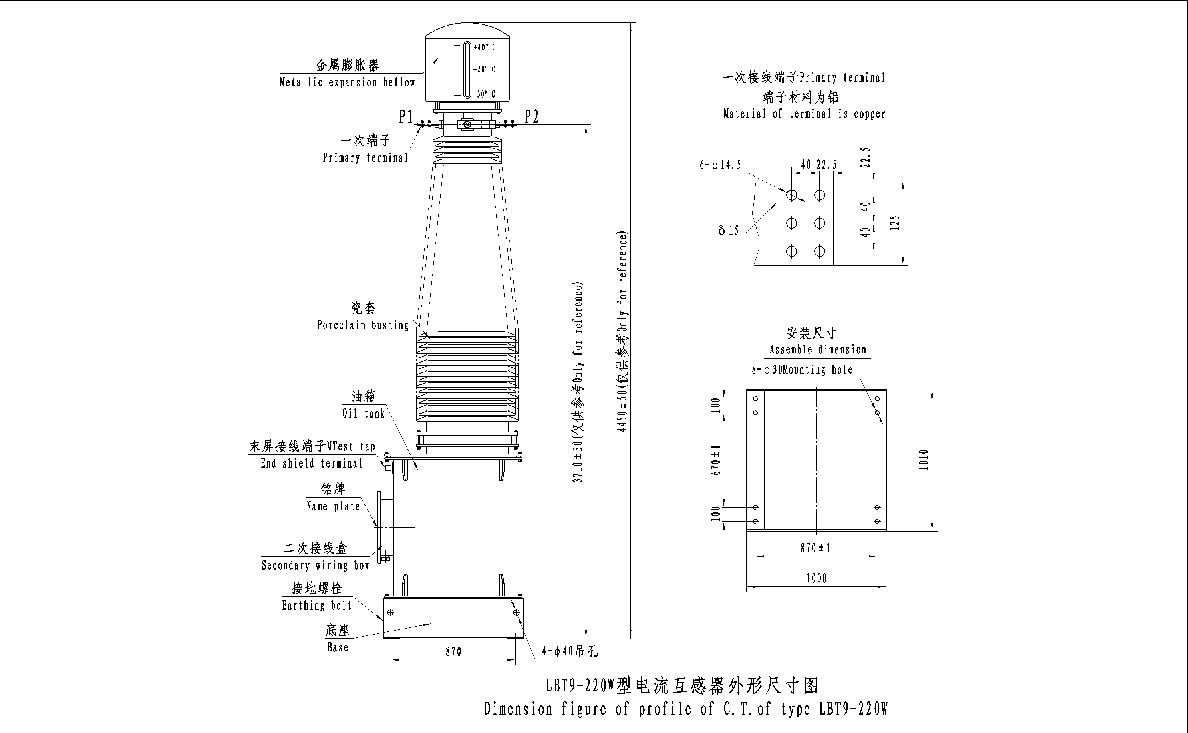

LB9T-220W电流互感器代表产品
LB9T-220W current transformer
产品代号Drawing Cat. No |  | 39001WB | 39002AWB |  | 39002CWB | 39002DWB | 39008AWB
额定电流比，A  Rated current ratio，A |  | 2×1250/1  抽头Tap:2×750/1 | 1500-3000/1 |  | TPY: 2×800/1  5P，0.5，0.2S: 2×800/5  5P，0.5，0.2S抽头Tap:2×600/5 | 2500/1 | 2×1250/1  抽头Tap:2×625/1
二次组合  Secondary Combination |  | 0.2/5P/TPY/TPY/  TPY/TPY | 0．2S/0.5/5P/5P  /TPY/TPY |  | TPY/TPY/5P/5P/5P/0.5/0.2S | TPY/TPY/5P/  5P/5P/0.5/0.2S | 0.2S/0.5/5P/5P  /TPY/TPY
二次出线端子  Secondary terminal |  | 1S1-1S2-1S3  2S1-2S2  3S1-3S2  4S1-4S2  5S1-5S2  6S1-6S2 | 1S1-1S2-1S3  2S1-2S2-2S3  3S1-3S2  4S1-4S2  5S1-5S2  6S1-6S2 |  | 1S1-1S2  2S1-2S2  3S1-3S2-3S3  4S1-4S2-4S3  5S1-5S2-5S3  6S1-6S2-6S3  7S1-7S2-7S3 | 1S1-1S2  2S1-2S2  3S1-3S2  4S1-4S2  5S1-5S2  6S1-6S2  7S1-7S2 | 1S1-1S2-1S3  2S1-2S2-2S3  3S1-3S2  4S1-4S2  5S1-5S2  6S1-6S2
准确级  Accuracy Class |  | 5P，TPY，0.2 | 5P，TPY，0.5，0.2S |  | 5P，TPY，0.5，0.2S | 5P，TPY，  0.5，0.2S | 5P，TPY，  0.5，0.2S
额定输出，VA  Rated output，VA |  | 满匝Full turn:50 | 5P：50 |  | 满匝Full turn:50 | 5P：40  0.5：50  0.2S：50 | 满匝Full turn:50
 |  | 抽头Tap:30 | 0.5  0.2S | 满匝Full turn:30 | 抽头Tap:30 | 5P：40  0.5：50  0.2S：50 | 抽头Tap:30
 |  | 抽头Tap:30 | 0.5  0.2S | 抽头Tap:20 | 抽头Tap:30 | 5P：40  0.5：50  0.2S：50 | 抽头Tap:30
准确限值系数  Accuracy limit factor |  | 20 | 30 |  | 30 | 20 | 30
仪表保安系数  Instrument security factor |  |  | ≤5 |  | ≤5 | ≤5 | ≤5
额定短时热电流，kA  Rated short time thermal current，kA |  | 63，3s | 50，3s |  | 50，3s | 50，3s | 50，3s
额定动稳定电，kA  Rated dynamic current，kA |  | 160 | 125 |  | 125 | 125 | 125
TPY级准确限制条件 | 对称短路电流倍数K_{SSC}  Symmetrical short-circuit current factor | 3S、4S：15 | 20 |  | 30 | 15 | 20
TPY级准确限制条件 | 对称短路电流倍数K_{SSC}  Symmetrical short-circuit current factor | 5S、6S：20
TPY级准确限制条件 | 额定电阻性负荷R_{b}，Ω  Rated resistive burden | 15 | 12 |  | 10 | 20 | 10
TPY级准确限制条件 | 一次时间常数T_{P}，ms  Primary time constant | 60 | 100 |  | 80 | 200 | 100
TPY级准确限制条件 | 规定的工作循环  Specified duty cycle | C-0.1s-O-0.5s-  C-0.04s-O | C-0.1s-O-0.3s-  C-0.05s-O |  | C-0.1s-O-0.8s-  C-0.1s-O | C-0.1s-O | C-0.1s-O-0.5s-  C-0.04 s-O
TPY级准确限制条件 | 剩磁系数  Remanence factor | ≤0.1 | ≤0.1 |  | ≤0.1 | ≤0.1 | ≤0.1
TPY级准确限制条件 | 对称短路电流直流分量  Rated symmetrical short-circuit current direct current | 100% | 100% |  | 100% | 100% | 100%

